|  |  |
| --- | --- |
| **King Fahd University of Petroleum & Minerals**  **College of Engineering Sciences**  **Electrical Engineering Department** |  |

**EE 462 Electrical Machine**

**Project**

**closed loop speed control for Three-phase induction motor using voltage-fed inverter.**

**Term 222**

**Prepared by:**

|  |  |
| --- | --- |
| **NAME** | **ID** |
| ------ | ----- |

**Introduction:**

The aim of this project is to design speed control for a three-phase induction motor utilizing a closed loop using a voltage-fed inverter. First will control the speed of the motor by only varying the voltage supplied to the motor and then will move on to control the speed by varying the voltage and frequency. Finally, will compare between both cases in terms of the starting current, torque and rise time.

**Simulink connection for the motor without the speed control:**

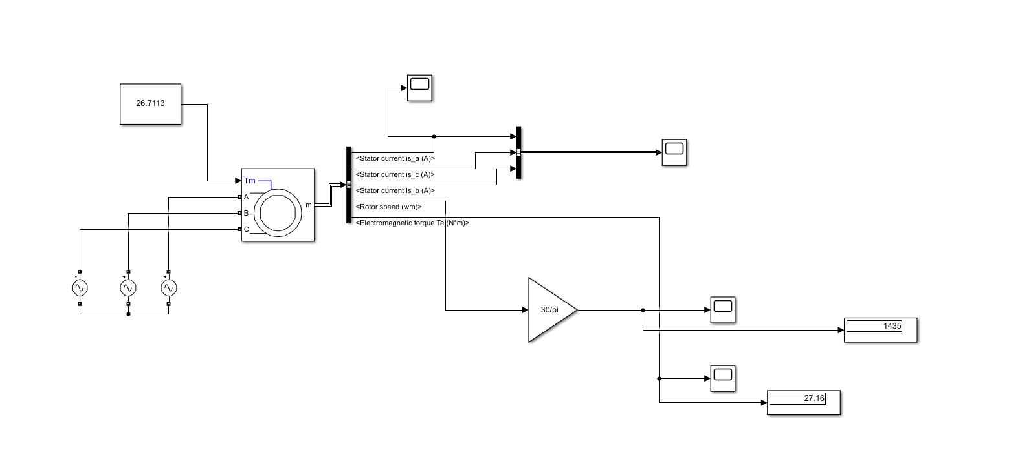

Figure 1 Block diagram

**Motor parameters:**

**Motor rated values.**

|  |  |
| --- | --- |
| 400V | **VL-L (rms)(V)** |
| 4 kw | **Pout(w)** |
| 50Hz | **Frequency(hz)** |
| 1430rpm | **Speed(rpm)** |
| (4kw)/(2*pi*1430/60) = 26.71N*m | **Torque(N*m)** |

**initial results:**

Figure 2 stator Current of the motor

Figure 3 torque of the motor

Figure 4 speed of the motor

**Components used in the speed control circuit:**

1. voltage-fed inverter (VFI)
2. pi controller

**Voltage-fed inverter (VFI):**

The following formulae was used to calculate the required dc voltage in the VFI to obtain a phase voltage of 326.59:

Vac = modulation index * (Vdc / 2)

Modulation index: 0.98

Vdc = (326.59*2)/ 0.98 = 666.51V

**Controlling the speed of the three-phase IM by varying the supplied voltage only (case 1):**

**Assumptions:**

1. The coefficients of PI controller are equal to P = 0.0001, I= 0.008
2. The set point for the speed is 800 rpm.

Figure 5 Block diagram for case 1

Figure 6 stator Current of the motor for case 1

Figure 7 torque of the motor for case 1

Figure 8 speed of the motor for case 1

**Note:**

It can be easily seen that the starting current reduced significantly in compression to not using any speed control method.

**Controlling the speed of the three-phase IM by V/F method (case 2):**

**Assumptions:**

1. The coefficients of the PI controller are equal to P = 0.01, I= 0.3
2. The set point for the speed is 800 rpm.

Figure 9 Block diagram for case 2

Figure 10 stator Current of the motor for case 2

Figure 11 torque of the motor for case 2

Figure 12 speed of the motor for case 2

**Note:**

It can be easily seen that the starting current is lower in comparison to case 1, also the response is much smoother.